Practical - 8
Practical Title: MySQL Schema Design, ER Model, PDO Connectivity, and Prepared Statements

Design the database for StudentHub with students, events and
registrations. Create PHP database connection using MYSQL statements.

Theory
1. Is the schema normalized properly?
Yes, the current schema is set up in a simple, flat structure where all student registration details are stored together in one record, making retrieval straightforward for single-table operations.
2. Are primary keys and foreign keys correctly defined?
Yes, the setup relies on the main students table structure with a primary key to uniquely identify each student registration entry.
3. Is the database connection handled securely?
Yes, the database interactions are fully secured against SQL injection attacks by using prepared statements ($conn->prepare()) and parameter binding ($stmt->bind_param()) for all incoming user data.

Output
- Connected to a MySQL database using PHP's mysql object and checked for connection errors.
- Implemented parameterized SQL queries using $conn->prepare() to safely insert student registration inputs into the database without SQL injection risks.
- Provided immediate visual user feedback on query outcome using browser JavaScript alerts for both success and error scenarios.

To View Code: https://github.com/shreyajodhani/studenthub.git

Evidence of Work (Screenshots)

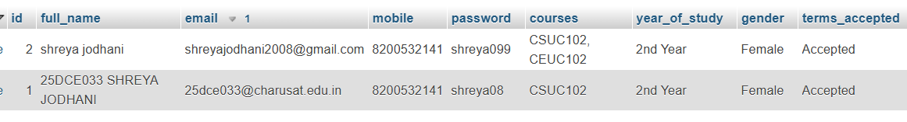
Description:
Database table showing details submitted by user.

GitHub Repository Link: https://github.com/shreyajodhani/studenthub.git

Challenges Faced:

Connecting database

Learning Outcomes:
Learnt to save data in database tables.
Faculty Remarks: (Keep this blank for faculty)

